# SOFTWARE REQUIREMENTS SPECIFICATION

### for

**TECHNICAL EDUCATION SOCIETY OF INDIA (TESI) MANAGEMENT SYSTEM**

***Prepared by***

|  |  |  |
| --- | --- | --- |
| **MERIT C THOMAS** | **700022** | [**meritcthomas@mca.ajce.in**](mailto:meritcthomas@mca.ajce.in) |

|  |
| --- |
| **Project Guide:** |
| **Date:**  **DEPARTMENT OF COMPUTER APPLICATIONS, AJCE** |

# CHAPTER - 1

**INTRODUCTION**

### PURPOSE

The purpose of this document is to provide a detailed description of the ‘Technical Education Society of India(TESI) Management System’. This SRS will give a complete understanding of the ‘TESI Management System to be constructed. The main purpose of ‘TESI Management System’ is to reduce the manual operation required to handle Institution registration, TESI member management, Hall ticket generation. The results can be useful for both institution and students to be the part of the society and to apply the examination conducted by the society and hence easily delivery of the Hall ticket .After completion of all these process the society deliver certificate for diploma an certificate course who are successfully completed the course ..

This is a database project which covers every aspect involved in a Technical Education Society Management System. The product will avoid the burden of hard copy storage. It will also provide data security as we are using the secured databases for maintaining the documents. We can also conserve the time and human resources for doing the same task. The data can be maintained for longer period with no loss of data.

### SCOPE

The TESI management system is a web based application. A Society maintains all the details related to the various students and institution involved in the effective functioning of the society. The TESI management system keeps all the details of the available institution and the details of the student who are attending the exam conducted by the society on various diploma and certificate course. It stores the day to day activities of society. It handles the registration made by the different institution to become member institution of the society. It also adds members to the admin panel who are interested to work as the part of the society member board. The thing to the apply to the admin panel is that, the person who are interested to become part of the admin panel should have minimum criteria to be the part of that according to the rules and regulations of the society. It keeps information about the institution and student who were the part of the society. Society also generates various types of reports in order to keep all the activities under proper control.

The syllabus of examination conducted to be published by the society admin panel. Society have the right to conduct certificate and diploma Couse on different courses which have affiliation to different member institution. If a new course be the part of the institution is to be founded the society have the right to add the new course to their database and can conduct examination on that too. These all functionalities are conducted on the basis of rule and regulations which were formed during the formation of this TESI society.

Major functional modules:

* + - Registration and login
    - Exam Management
    - Result Management
    - Course Management
    - Student Registration
    - Hall ticket Generation
    - TESI Management
  1. **DEFINITIONS, ACRONYMS, AND ABBREVIATIONS**

PHP-Personal Home Page JS-Java Script

AJAX- Asynchronous java script and XML HTML-Hypertext Markup Language

SQL-Structured Query Language

## REFERENCES

* + - Roger S Pressman, “Software Engineering”
    - [www.w3schools.com](http://www.w3schools.com/)
    - [www.stackoverflow.com](http://www.stackoverflow.com/)

## OVERVIEW

#### EXISTING SYSTEM

The existing system in a society done almost every activity manually, it includes student registration, institution membership, adding of new members to the current admin panel and hall ticket generation activities.

#### DRAWBACKS OF EXISTING SYSTEM

* + - No Online membership facility to institution.
    - No Online membership facility to Admin.
    - Manual Student Registration by institution.
    - Usual procedures for Hall ticket Generation.
    - Time consuming.

#### PROPOSED SYSTEM

The proposed system provides a registration and login for admin, institution and students too. It allows to manage the registration of institutions and students. It automates the student registration and hall ticket generation. It maintains the institutions information. The new person who likely to be part of admin panel can give request to the society through online.

The main features include:

* + - Syllabus Generation.
    - Courses Adding to society.
    - Detailed information of manager of institution.
    - Institution and Student details obtained easily.
    - Generating reports.
    - Register number allocation by admin.
    - Generation of Hall ticket.
    - Result publishing.

#### ADVANTAGES OF PROPOSED SYSTEM

The system is very simple in design and to implement. The system requires very low system resources and it will work in almost all configurations. It has got following features:

* + - Online Student registration.
    - Online Hall ticket availability.
    - Online result availability.
    - Time Saving
    - Security for data of institution, student, admin etc.

# CHAPTER - 2

**OVERALL DESCRIPTION**

## PRODUCT PERSPECTIVE:

The Technical Education Society of India (TESI) Management System is an independent product that automates all the tasks that are carried out by TESI society for enhancing technical education. The main purpose of the society is to promote technical education. TESI has been working hard to improve the technical talent of the students and Technicians. TESI conducting examinations in various member institutions these examinations popular among the technical Institutes. Various students got job in India and abroad with TESI certificates. It maintains all the details related to the various member institutions and their student information safely. It gives information about the certificate courses and diploma courses conducted by the society. It manages request by others who likely to be work with the society. It stores the day to day requests from both institutions and person who likely to be part of admin panel. It also information of invigilators whom go to different member institution for conducting examination of society. It keeps information about the members of admin panel it includes photos, signature, their institution details, contact address, email address and phone number etc. The registered institution gets TESI membership number and password through mail service. By using this membership number and password the individual institutions can enter the information about the student who are likely to be part of examination conducted by the society. The current working president have the right to controls the entire activities of the system for society.

## PRODUCT FUNCTIONS/FEATURES:

The objective is to build a software system that is user friendly and accurately generates and stores data that automates all the tasks in a TESI society. The software system should be convenient for its users. The aim of proposed system is to develop a system with improved facilities.

The major functional modules are:

#### Institution Registration and login

The TESI Management System allows the institution registration and login. The username and password used for login are send to the institution through E-mail or SMS (OTP). This is send after submitting membership form by institution available in website.

#### TESI Management

The System maintains information regarding the members of the admin panel. It keeps every details of members including signature, photo and, his institution details etc. It also manages the addition and deletion of TESI admin panel details.

#### Course Management

#### Manages the course of the society. It also adds new course to the society for conducting examination on that course that found in a particular institution. It also manages the syllabus associated with that course.

#### Result Management

#### Manages the result obtained from the admin. Student information and mark secured by each student on different subject are managed here.

#### Student Registration

#### Students of different member institution are registered by the institution itself. Student who are likely to attend diploma or certificate course examination are registered by institution.

#### Hall ticket Generation

#### Generate hall ticket to the student who were appearing the examination conducted by the society. Student basic information are entered in hall ticket. Exam centers are allocated to each student and its details are found in hall ticket. Control the hall ticket downloads that done by both students and institutions.

#### Exam Management

#### Manages the notification for different institution about exam and its timetable. Details of the invigilator are also provided for each member institution.

#### 

## USER CHARACTERISTICS:

The TESI Management System has 3 users.

**2.3.1Admin Module**

Admin module control overall every activity of this system. They provide proper TESI membership number and password to institutions who have been where requested to become member institution. Admin provide information about the syllabus and examination time table to the institution module.

**2.3.2 Institution Module**

Institution module enter into their own pages by using the TESI membership number and password which is given by admin to institution through mail services. Here the institution can add information about the students into the site which is next verified by admin and provide a registration number to the students.

**2.3.3 Students Module**

Students can login to site by using the registration number and date of birth and download the hall ticket from the site itself.

## OPERATING ENVIRONMENT

#### Hardware Specification

Processor : Pentium IV/AMD Dual core or above

RAM : 2 GB and above

Hard disk : 500 GB and above

#### Software Specification

Front End : PHP (Code igniter)

Backend : MySQL

Client on PC : Windows 7 and above. Technologies used : JS, HTML5, AJAX, J Query

#### CONSTRAINTS: */

It provides the genera1 description of the constraints such as regulatory policies, audit functions, reliability requirements, and so on.

#### USER DOCUMENTATION

The ‘TESI Management System’ will provide a user’s manual for the administrator and manager. To assist the user in understanding the product better and to assist them in better utilization of the product and its features, we will be providing an interactive user interface (in DOC format).

#### ASSUMPTION AND DEPENDENCY

We are assuming that the users will not use our product to download copyright. Also, we expect that the users not only use the software to view resources, they will also be updating details and resources for being viewed by other users. We also assume that product users will not do malicious activities on the software.

# CHAPTER - 3

**SPECIFIC REQUIREMENTS**

### EXTERNAL INTERFACE REQUIREMENTS

The “**Technical Education Society of India (TESI) Management System And Market Basket Analysis**” will use the following input/output devices for a personal computer. The external interfaces are:

* + - Keyboard
    - Mouse
    - Monitor
    - Printer
    - Mobile phone

#### User Interfaces

|  |  |
| --- | --- |
| **FORMS** | **DESCRIPTION** |
| Home | Log into the site as an Administrator,  Institution, Manager, or Student. |
| Institution Registration | Institution register to become member institution of the society and get access to register student for exam conducted by the society. |
| Student Registration | Student of different member institution are registered by the institution itself for examination conducted by the society. |
| Syllabus Management | Courses of different institution and its syllabus are managed here. |
| Exam Management | Exam and timetables are managed here and the notification are given to each member institution. |
| Result Management | Result of each student on different subject are  shown and are easily available. |

* + 1. **Hardware Interfaces/\***

**TESI Management System is** a web based application.

#### Software Interfaces

Database Server: MySQL Development End: PHP Client on PC: Any Browser

#### Communications Interfaces */

* 1. **FUNCTIONAL REQUIREMENTS**

Functional requirements define the fundamental actions that system must perform. The functional requirements for the system are divided into some main categories Institution Registration, Hall ticket Management, Result Management, Student Registration, Exam Management.

#### Registration

* + - 1. Introduction

The user can register in to the system. There is an institution registration and student registration. The students are registered by the institution. The institution can directly register their details.

* + - 1. Inputs

In this module, for institution registration, the institution information like institution name, affiliation, year of establishment, courses, Name of the manager etc are entered into the database.

* + - 1. Processing

After institution registration, the username and password are send to them by mail or SMS. Then the institution can login to the site and can update institute information and password.

* + - 1. Outputs

When registration is completed, a success message is displayed in case of institution.

* + - 1. Error Handling

During the registration process, all the inputs are validated and if there is any error, it is displayed. If a username is already in use, it also displayed.

#### Exam Management

* + - 1. Introduction

This module is for exam management. It manages exam and its time table conducted at different member institution.

* + - 1. Inputs

The subject and date at which exam for particular subject is conducted.

* + - 1. Processing
      2. Outputs

The time table of examination conducted under different member institution is viewed.

* + - 1. Error Handling

If the date or subject entered incorrectly, it can be changed.

#### Result Management

3.2.3.1 Introduction

This module is for handling the leave applications. The employees apply for leave. 3.2.3.2Inputs

date, reason, type of leave, and session of day 3.2.3.3Processing

The admin can approve or reject the leave applications. 3.2.3.4Outputs

The leave status can be checked by the employee. 3.3.3.5Error Handling

If leave for a date is already applied, and if employees try to apply it again, it is not entered into the database.

#### 3.2.4Hall ticket Generation

3.2.4.1Introduction

This module is for generating hall ticket for students who were appearing examination conducted at various institution.

3.2.4.2Inputs

The basic information about student, course they are appearing are entered into the database.

3.2.4.3Processing

The students satisfying minimum attendance percentage and other criteria for selected for examination.

3.2.4.4Outputs

Proper register number and exam center are allocated to each student who satisfying minimum requirement criteria.

3.2.4.5Error Handling

Incorrect register number of students are eliminated.

#### INPUT FORMS

* + 1. **OUTPUT FORMS**

**3.7 Other Documents**

**3.7.1 DATA FLOW DIAGRAM**

**CONTEX DIAGRAM OF TESI MANAGEMENT**

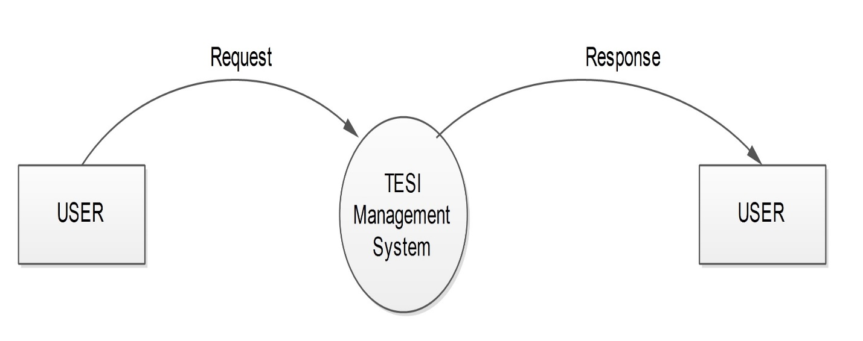

**LEVEL -1 DFD FOR ADMIN**

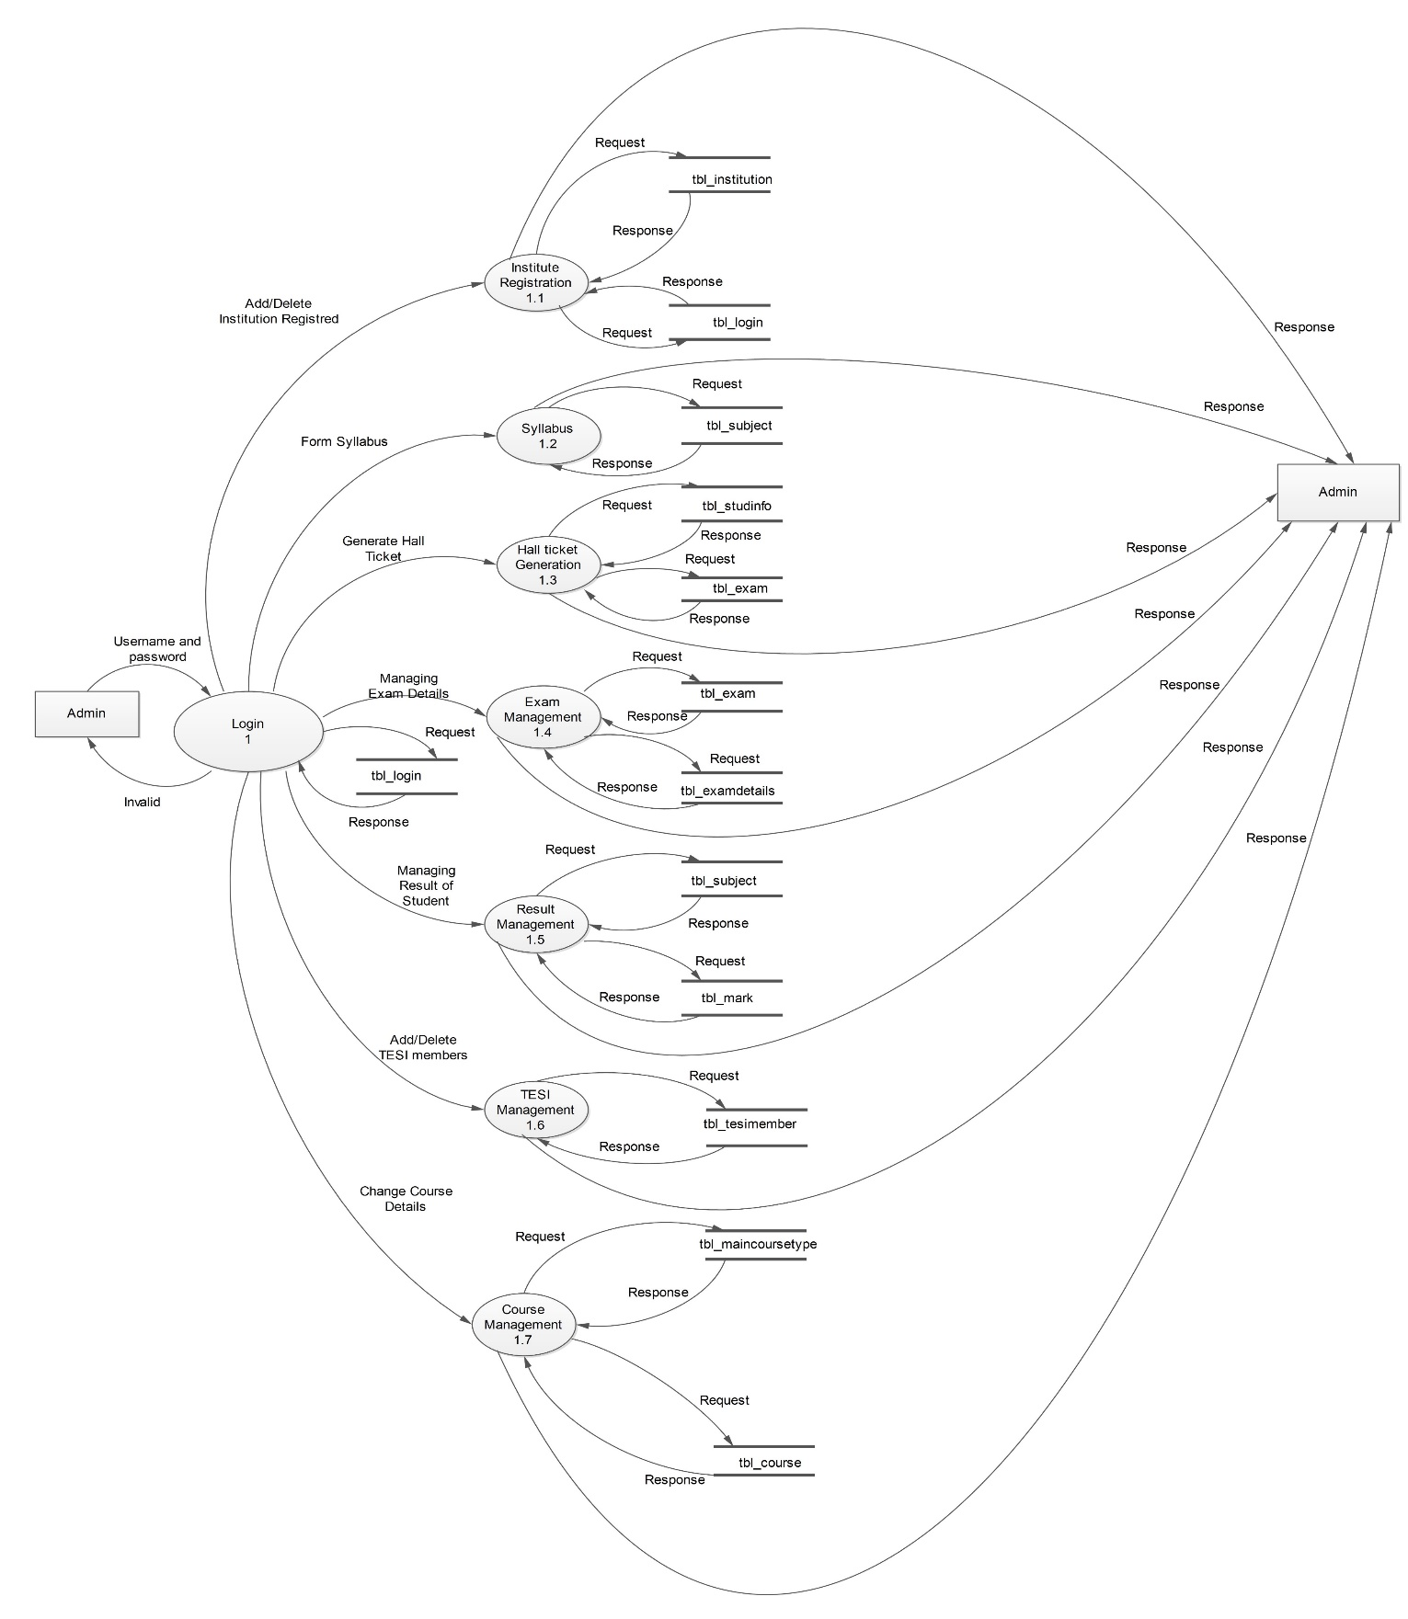

**LEVEL-1 DFD FOR INSTITUTION**

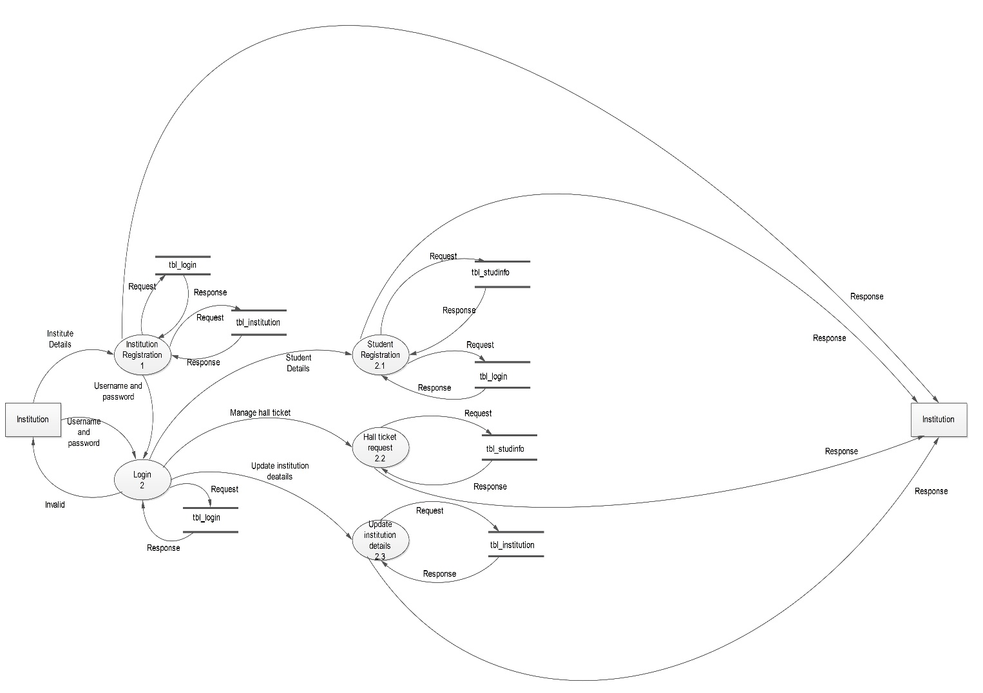

**LEVEL-1 DFD FOR STUDENT**

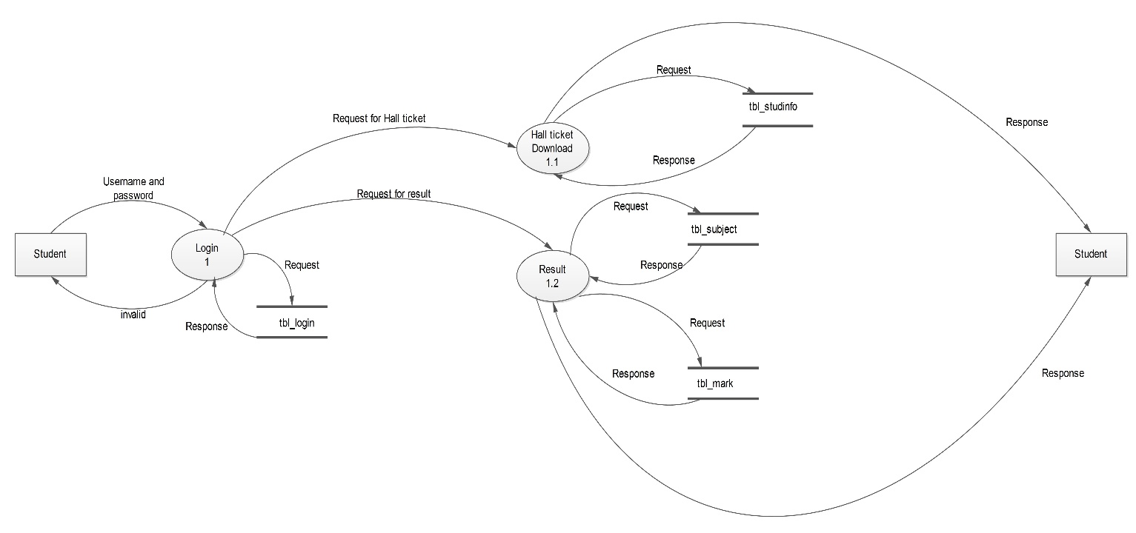

### USE CASE DIAGRAM

### Home page

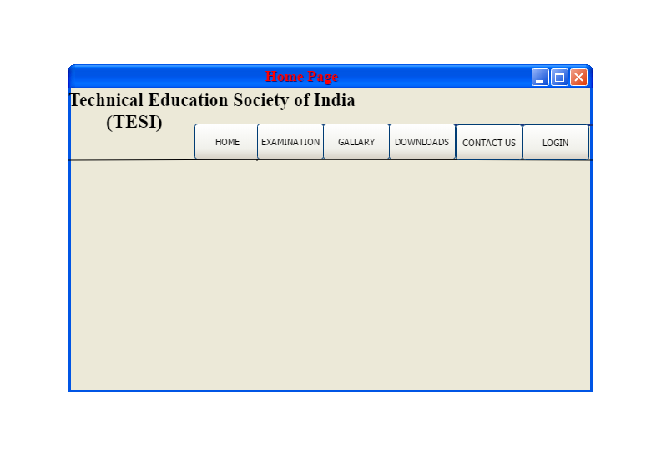

**Login page**

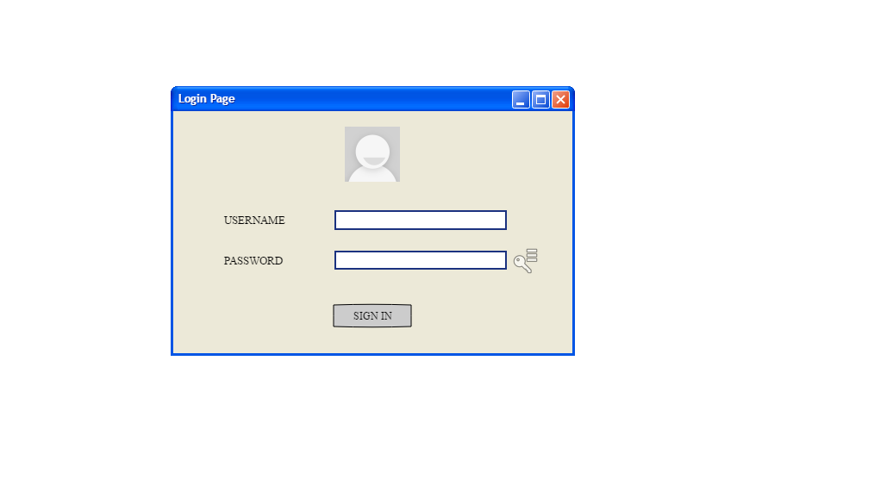

**institution registration Page**

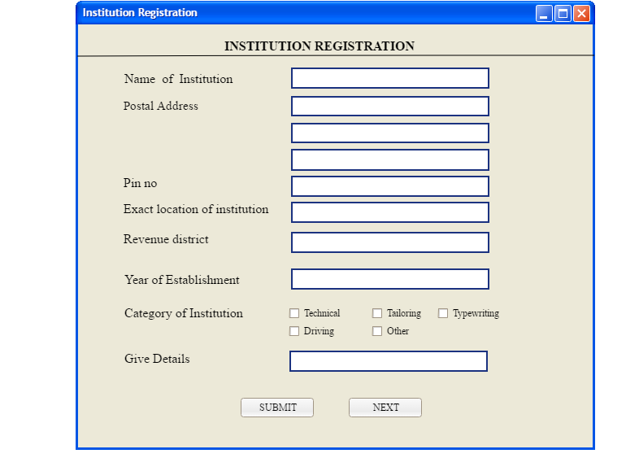

**Exam Registration Page**

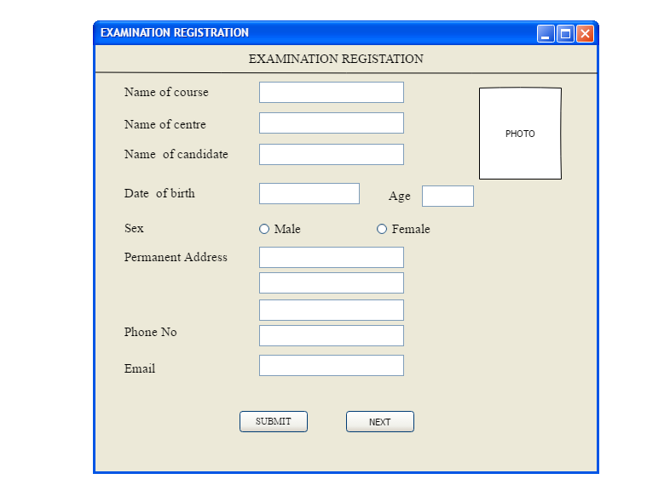

**Admin page**

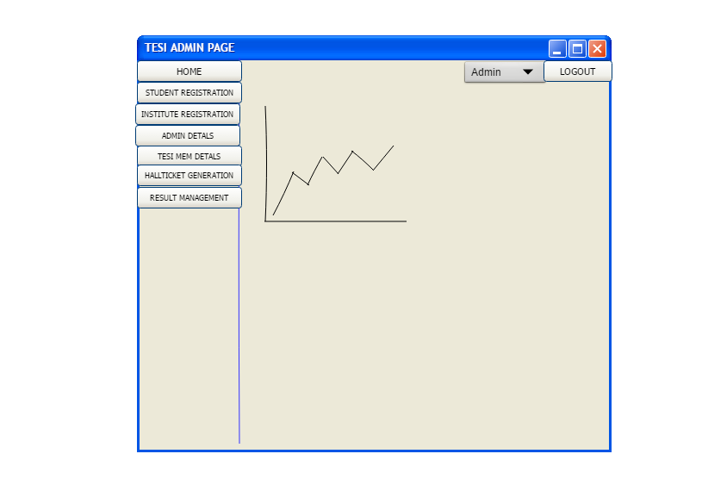

* + 1. **SEQUENCE DIAGRAM**

**3.7.4 TABLE DESIGN**

**1.Tbl_login**

Primary key:l_id

|  |  |  |  |
| --- | --- | --- | --- |
| FIELD NAME | FIELD TYPE | SIZE | DESCRIPTION |
| l_id | int | 5 | Login_id |
| username | varchar | 15 | username |
| password | varchar | 10 | password |
| role | int | 5 | Role to the society |
| l_status | int | 5 | Login status |

**2.tbl_institution**

Primary key:inst_id

Foreign key:l_id,add_id,m_id,course_id,m_id

|  |  |  |  |
| --- | --- | --- | --- |
| FIELD NAME | FIELD TYPE | SIZE | DESCRIPTION |
| Inst_id | int | 5 | Institute id |
| l_id | int | 5 | Login id |
| Course_id | int | 5 | Course id |
| add_id | int | 5 | Address id |
| m_id | int | 10 | Manager id |
| Inst_name | varchar | 20 | Institute name |
| Inst_est | int | 10 | Institute established year |
| Inst_recg | varchar | 10 | Institute recognition |
| Inst_afln | varchar | 10 | Institute affiliation |
| Inst_tstudent | int | 10 | Total number of student in institution |
| Inst_staff | int | 10 | Institute staff |
| Inst_nstaff | int | 7 | Institute nonstaff |
| Inst_expn | varchar | 8 | Institute explanation |
| Tesi_memno | int | 10 | Tesi member number |
| Inst_status | int | 5 | Institute status |

**3.tbl_district**

Primary key:dis_id

Foreign key:state_id

|  |  |  |  |
| --- | --- | --- | --- |
| FIELD NAME | FIELD TYPE | SIZE | DESCRIPTION |
| dis_id | int | 5 | District id |
| state_id | int | 5 | State id |
| dis_name | varchar | 10 | District name |
| dis_status | int | 5 | District status |

**4.tbl_state**

Primary key:state_id

|  |  |  |  |
| --- | --- | --- | --- |
| FIELD NAME | FIELD TYPE | SIZE | DESCRIPTION |
| State_id | int | 5 | State id |
| S_name | varchar | 10 | State name |
| S_status | int | 5 | State status |

**5.tbl_manager**

Primary key:m_id

Foreign key:inst_id,add_id

|  |  |  |  |
| --- | --- | --- | --- |
| FIELD NAME | FIELD TYPE | SIZE | DESCRIPTION |
| m_id | int | 5 | Manager id |
| Inst_id | int | 5 | Institute id |
| Add_id | int | 5 | Address id |
| M_name | varchar | 10 | Manager name |
| M_phone | int | 15 | Manager phone number |
| M_email | int | 20 | Manager email |
| M_status | int | 5 | Manager status |

**6.tbl_address**

Primary key:add_id

Foreign id:dist_id

|  |  |  |  |
| --- | --- | --- | --- |
| FIELD NAME | FIELD TYPE | SIZE | DESCRIPTION |
| add_id | int | 5 | Address id |
| Dist_id | int | 5 | District id |
| h_name | varchar | 10 | House name |
| Strt1 | varchar | 10 | Street1 |
| Strt2 | varchar | 10 | Street2 |
| Pin | int | 5 | Pin number |
| role | int | 5 | Role to the society |
| addstatus | int | 5 | Address status |

**7.tbl_maincoursetype**

Primary key:mc_id

|  |  |  |  |
| --- | --- | --- | --- |
| FIELD NAME | FIELD TYPE | SIZE | DESCRIPTION |
| mc_id | int | 5 | Main course id |
| course_type | varchar | 10 | Type of course |
| mc_status | int | 5 | Main course status |

**8.tbl_category**

Primary key:cat_id

|  |  |  |  |
| --- | --- | --- | --- |
| FIELD NAME | FIELD TYPE | SIZE | DESCRIPTION |
| cat_id | int | 5 | Category id |
| cat_name | Varchar | 10 | Category name |
| cat_status | int | 10 | Category status |

**9.tbl_course**

Primary key:course_id

Foreign key:cat_id,mc_id

|  |  |  |  |
| --- | --- | --- | --- |
| FIELD NAME | FIELD TYPE | SIZE | DESCRIPTION |
| couse_id | int | 5 | Course id |
| cat_id | int | 5 | Category id |
| mc_id | int | 5 | Main course id |
| c_name | varchar | 10 | Course name |
| c_duration | int | 5 | Couse duration |
| c_status | int | 5 | Course status |

**10.tbl_subject**

Primary key:s_id

Foreign key:cat_id,mc_id

|  |  |  |  |
| --- | --- | --- | --- |
| FIELD NAME | FIELD TYPE | SIZE | DESCRIPTION |
| s_id | int | 5 | Subject id |
| cat_id | int | 5 | Category id |
| mc_id | int | 5 | Main course id |
| sub_code | int | 10 | Subject code |
| sub_name | varchar | 10 | Subject name |
| min_mark | int | 10 | Minimum mark |
| max_mark | int | 10 | Minimum mark |
| syllabus | varchar | 20 | Exam syllabus |
| s_status | int | 5 | Subject status |

**11.tbl_mark**

Primary key:mark_id

Foreign key:studinfo_id,mem_id

|  |  |  |  |
| --- | --- | --- | --- |
| FIELD NAME | FIELD TYPE | SIZE | DESCRIPTION |
| Mark_id | int | 8 | Mark id |
| Studinfo_id | int | 10 | Student information id |
| Mem_id | int | 10 | Tesi member id |
| Mark | int | 20 | Marks |
| Mrk_status | int | 10 | Mark status |

**12.tbl_exam**

Primary key:exm_id

Foreign key:inst_id,course_id,mem_id

|  |  |  |  |
| --- | --- | --- | --- |
| FIELD NAME | FIELD TYPE | SIZE | DESCRIPTION |
| Exm_id | int | 5 | Exam id |
| Inst_id | int | 5 | Institute id |
| Course_id | int | 5 | Course id |
| Mem_id | int | 5 | Tesi member id |
| Exm_centre | Varchar | 20 | Exam centre |
| Exm date | date |  | Exam date |
| Exm status | int | 5 | Exam status |

**13.tbl_examdetails**

Primary key:formcid

Foreighn key:inst_id,studinfo_id,exm_id

|  |  |  |  |
| --- | --- | --- | --- |
| FIELD NAME | FIELD TYPE | SIZE | DESCRIPTION |
| formcid | int | 5 | Formcid |
| Inst_id | int | 5 | Institute id |
| Studinfo_id | int | 10 | Student information id |
| Exm_id | int | 5 | Exam id |
| exmfee | float | 10 | Examfees |
| fremark | varchar | 10 | Formcremark |
| fstatus | int | 5 | Formc status |

**14.tbl_studinfo**

Primary key:studinfo_id

Foreighn key:course_id,add_id,inst_id,l_id

|  |  |  |  |
| --- | --- | --- | --- |
| FIELD NAME | FIELD TYPE | SIZE | DESCRIPTION |
| Studinfo_id | int | 5 | Student information id |
| Course_id | int | 5 | Course id |
| Add_id | int | 5 | Address id |
| inst_id | int | 5 | Institute id |
| l_id | int | 5 | Login id |
| Stud_name | varchar | 20 | Student name |
| Stud_dob | date |  | Student dob |
| Stud_age | int | 10 | Student age |
| Stud_sex | varchar | 10 | Student sex |
| Stud_regno | int | 10 | Student registration number |
| Stud_qual | varchar | 10 | Student qualification |
| Stud_sig | varchar | 20 | Student signature |
| Stud_photo | varchar | 20 | Student photo |
| S_studinfo | int | 20 | Status studentinformation |

**15.tbl_attendance**

Primary key:att_id

Foreign key:studinfo_id,inst_id,s_id

|  |  |  |  |
| --- | --- | --- | --- |
| FIELD NAME | FIELD TYPE | SIZE | DESCRIPTION |
| Att_id | int | 7 | Attendance id |
| Studinfo_id | int | 5 | Student information id |
| Inst id | int | 5 | Institute id |
| S_id | int | 5 | Subject id |
| date | date | 10 | Date |
| S_att | int | 10 | Status attendance |

**16.tbl_tesimember**

Primary key:mem_id

|  |  |  |  |
| --- | --- | --- | --- |
| FIELD NAME | FIELD TYPE | SIZE | DESCRIPTION |
| Mem_id | int | 5 | Member id |
| name | varchar | 20 | Member name |
| role | int | 5 | Role to the society |
| sig | varchar | 20 | Signature |
| dob | date | 10 | Date of birth |
| photo | varchar | 20 | Photo of member |
| email | varchar | 20 | Email address |
| phno | int | 20 | Phone number |
| Mem_status | int | 5 | Member status |